User's Guide

Personal Expense Tracker
CMSC 495 Computer Science Capstone

Table of Contents
Introduction 2
Overview of the Software 2
Purpose of the User Guide 2
Target Audience 2
Getting Started 3
System Requirements 3
Installation Instructions: Local Setup 3
Installation Instructions: Docker Setup 3
First-Run Behavior 3
User Interface Overview 3
Standards and Guidelines 4
Using the Software 4
Registering a New User 4
Logging In 4
Adding an Expense 4
Updating an Expense 5
Deleting an Expense 5
Adding a Custom Category 5
Searching Expenses 5
Reviewing Totals and Reports 5
Logging Out 5
Troubleshooting Tips 6
Reference 6
Glossary of Terms 6
Index 7
References 7

Introduction
The Personal Expense Tracker is a desktop budgeting application designed to help users capture personal spending, organize transactions by category, search historical records, and review totals through charts. The software combines a JavaFX desktop interface, a Spring Boot application layer, and an embedded SQLite database so that users can manage expense data locally without installing a separate database server.
This guide explains how to install and start the application, navigate the interface, complete common tasks, and solve routine problems without developer assistance. It is intended to support first-time users, instructors reviewing the project, and team members who need a clear operating reference.

Overview of the Software
The application supports the following core functions:
- Register a new user account.
- Log in with an existing account.
- Add expenses with a category, amount, description, and date.
- Update an existing expense after selecting it from the table.
- Delete an expense with confirmation.
- Add custom categories in addition to the six system defaults.
- Search expense history by category, description, or date.
- Review total spending and chart-based summaries by category.

Purpose of the User Guide
The purpose of this guide is to help users:
- Install the software correctly.
- Understand the main screens and controls.
- Perform the application's major tasks in the correct order.
- Follow data-entry standards for clean and accurate records.
- Resolve common setup and runtime issues independently.

Target Audience
This guide is written for three primary audiences:
- Course instructors and project evaluators reviewing the capstone submission.
- End users who want to track personal expenses using the desktop application.
- Student team members who need an operational reference during development or demonstration.

Getting Started
System Requirements
The table below identifies the system requirements confirmed by the project's build configuration and documentation:

Component | Version / Spec | Notes
Java Development Kit | 21 (LTS) | Required. Verify with: java -version
Apache Maven | 3.6.3 or newer | Resolves all dependencies. Verify with: mvn -version
JavaFX | 21.0.2 | Auto-resolved via Maven - no manual install needed.
Python | 3.8+ (optional) | Needed only for CSV/JSON import-export.
Operating System | Windows 10/11 | Also supported: macOS, Linux with Java 21.
Docker Desktop | Latest | Required only for the Docker launch option.
RAM | 8 GB minimum | 16 GB recommended when running Docker containers.

Installation Options
Users can run the application in one of two ways. The Docker option is generally the easiest for project demonstrations because it avoids local Maven and JavaFX setup. The local setup is recommended for active development and testing.

Installation Instructions: Local Setup
Use these steps when Java 21 and Maven are already installed on the machine:
- Download or clone the project repository from GitHub.
- Open a terminal in the cmsc495-expense-tracker-main folder.
- Confirm Java 21 is active:
java -version
- Confirm Maven is available:
mvn -version
- Build the application:
mvn clean install
- Start the desktop application:
mvn javafx:run

Note: The application creates a local SQLite file named expense_tracker.db in the project directory on first launch. This file persists all user data between sessions.

Installation Instructions: Docker Setup
Use these steps when Docker Desktop or Docker Engine is installed:
- Open a terminal in the cmsc495-expense-tracker-main folder.
- Start the Docker daemon if it is not already running.
- Run:
docker compose up --build
- Open a web browser and navigate to:
http://localhost:6080/vnc.html
- Interact with the JavaFX application inside the browser window via noVNC.

Note: In the Docker configuration, the SQLite database is stored in a Docker named volume so that user data remains available after the container stops and restarts.

First-Run Behavior
On first launch, the application automatically creates the following database tables:
- user - stores registered user accounts.
- category - stores system default and user-created categories.
- expense - stores all spending records linked to users and categories.

The following six default categories are seeded automatically and are available to every user:
- Food
- Transportation
- Housing
- Entertainment
- Healthcare
- Other

User Interface Overview
The application uses two primary screens: the Login Screen and the Dashboard.

Login Screen
The Login Screen is the first screen displayed when the application launches. It contains:
- Application title label.
- Email address input field.
- Password input field.
- Login button - authenticates and opens the Dashboard.
- Register button - creates a new account and opens the Dashboard.
- Status label - displays authentication error messages.
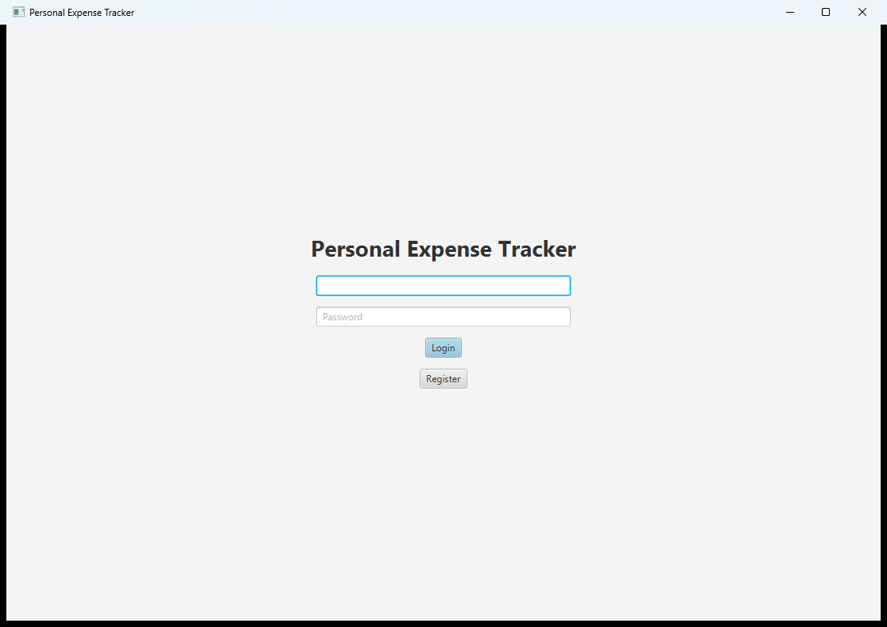
Figure 1: Login Screen - annotated with numbered callouts for each control

Dashboard Screen
The Dashboard is the main working screen, arranged in three work areas:
- Left panel: expense-entry form (category, amount, description, date), Add Expense, Add Custom Category, and Search controls.
- Centre panel: expense table and Total Spent label.
- Right panel: Expense Breakdown pie chart and Spending by Category bar chart.
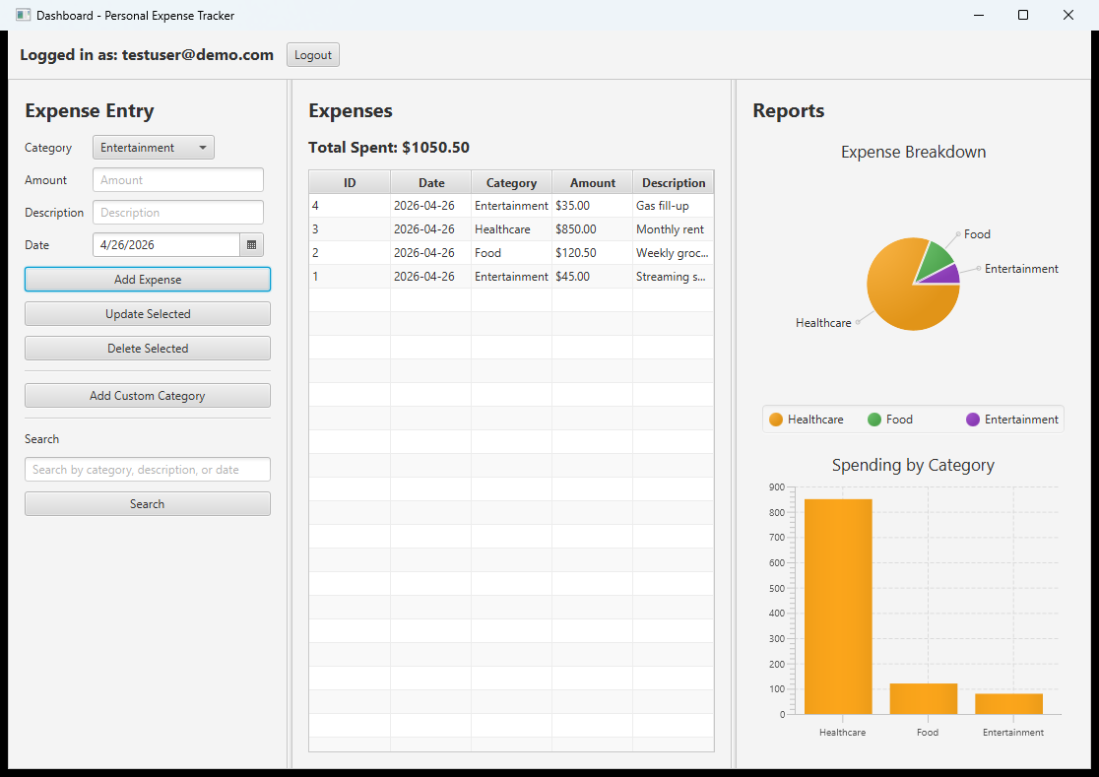
Figure 2: Dashboard Screen - full view with all three panels labelled
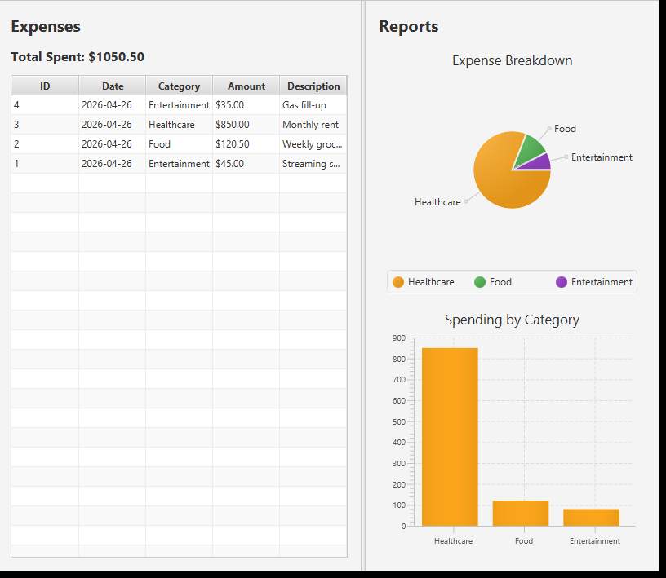
Figure 3: Dashboard - zoomed view of the expense table and chart area
Standards and Guidelines
To make the best use of the software, users should follow these data-entry standards:

- Use a valid, memorable email address when registering. Emails are stored in lowercase.
- Enter the password consistently - the application requires the exact password at every login with no recovery option.
- Enter amounts as numeric values only, such as 12.50 or 99.99. Do not include currency symbols.
- Always select a category from the dropdown before saving an expense. Category is a required field.
- Use the date picker to select the transaction date to ensure a valid format.
- Use short, meaningful descriptions such as Groceries, Gas, or Monthly streaming subscription.
- Create custom categories only when none of the six defaults fits the transaction.
- Avoid creating duplicate custom categories with slightly different spelling.

Best Practice: Consistent category and description naming makes searching, totals, and charts significantly easier to interpret over time.

Using the Software
Registering a New User
Use registration the first time you access the application. An account is required before any features can be used.
- Open the application.
- Enter an email address in the email field.
- Enter a password in the password field.
- Click Register.
- If registration succeeds, the application automatically opens the Dashboard.

Important: Email addresses are normalized to lowercase before storage. If the email already exists, registration fails and the user remains on the Login Screen.

Logging In
Use these steps after your account has been created:
- Enter your registered email address.
- Enter your password.
- Click Login.
- If the credentials are correct, the Dashboard opens.

If login fails, the screen displays: Invalid email or password. Verify the credentials and try again. If you have not yet created an account, click Register.

Navigating the Dashboard
The Dashboard provides access to all core features from a single screen. The three panels are always visible simultaneously, with the left panel for data entry, the center for reviewing records, and the right for visual summaries.

Adding an Expense
Use these steps to record a new transaction:
- Open the category dropdown and choose the appropriate category.
- Enter the amount in the Amount field (numeric values only, e.g. 25.50).
- Optionally enter a description in the Description field.
- Select the transaction date using the date picker.
- Click Add Expense.

Expected result: The record appears in the expense table, the Total Spent label updates, and both charts refresh.
Validation: Category, amount, and date are required. If the amount is not numeric, the application displays: Amount must be a valid number.

Selecting an Existing Expense
Before updating or deleting a record, it must first be selected from the expense table:
- Click the desired row in the expense table.
- Confirm that the form fields automatically populate with that row's category, amount, description, and date.
- Proceed to update or delete as needed.

Updating an Expense
- Click the expense row you want to modify.
- Confirm the form fields populate with the current values.
- Change one or more fields.
- Click Update Selected.
- Confirm the revised data appears in the table and totals refresh.

Note: If no row is selected, the application displays: Please select an expense to update.

Deleting an Expense
- Select the expense row in the table.
- Click Delete Selected.
- Read the confirmation dialog.
- Click OK to confirm the deletion.

Expected result: The expense is removed, the Total Spent label updates, and the charts refresh. Deletion is permanent and cannot be undone.
Note: If no expense is selected, the application displays: Please select an expense to delete.

Adding a Custom Category
The application provides six default categories. Users may create additional categories as needed:
- Click Add Custom Category.
- Enter the category name in the dialog box (e.g. Books, Pet Care, or Tuition).
- Click the dialog confirmation button.
- Open the category dropdown to verify the new category appears.

Searching Expenses
The search feature filters the expense table based on text entered in the Search field:
- Type a search term into the Search field.
- Click Search.
- Review the filtered results in the expense table.

The search matches against category name, expense description, and transaction date text. Searches are case-insensitive, partial matches are supported, and date searches accept partial text such as 2026-03.

Reviewing Totals and Reports
Total Spent: The label above the table shows the running sum of all expenses for the current user formatted as Total Spent: $0.00.

Expense Breakdown (Pie Chart): Displays each category's proportional share of total spending. Hover over a slice to see the category name and total.

Spending by Category (Bar Chart): Compares category totals side by side, making it easy to identify the highest-cost categories at a glance.
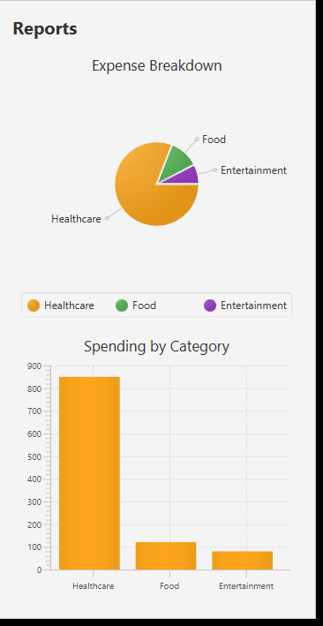
Figure 4: Dashboard Charts - Pie chart and Bar chart with sample expense data

Logging Out
Use Logout when a session is complete or when a different user needs access on the same machine:
- Click Logout at the top of the Dashboard.
- The application returns to the Login Screen.
- All data remains saved in the database for the next login.

Troubleshooting Tips
Problem: The Application Will Not Start Locally
- The machine is using Java 17 instead of Java 21. Install or switch to JDK 21 and verify with java -version.
- Maven is not installed or not on the system path. Install Maven and verify with mvn -version.
- Dependencies did not build successfully. Run mvn clean install again from the project root.
- JavaFX modules did not resolve correctly. Always use mvn javafx:run rather than running class files manually.

Problem: The Docker Version Will Not Start
- Docker Desktop is installed, but the daemon is not running. Start Docker Desktop and wait for initialization.
- Port 6080 is in use. Stop the conflicting service or change the port in docker-compose.yml.
- Browser cannot connect to noVNC. Confirm docker compose up --build completed, then open http://localhost:6080/vnc.html.

Problem: Registration Fails
- The email address may already exist. Try clicking Login instead.
- Leading or trailing spaces in the email or password field. Re-enter carefully.
- The database may carry prior data from an earlier test session. Reset the database only if appropriate.

Problem: Login Fails
- Verify the email and password match the registered account exactly. Passwords are case-sensitive.
- If no account exists yet, click Register on the Login Screen.

Problem: I Cannot Add an Expense
- No category was selected from the dropdown.
- The Amount field is blank or contains non-numeric characters.
- The date field is blank - use the date picker to select a date.

Problem: Update or Delete Does Not Work
- No row is selected in the expense table. Click a row first.
- The row may have been filtered out by an active search. Clear the search and try again.

Problem: Search Results Look Incomplete
- The search field may still be filtering from an earlier query. Clear and search again.
- Try a shorter partial match if the full term does not return results.
- For dates, use partial text such as 2026-04 or a full date such as 2026-04-19.

Problem: The Charts Are Empty
- No expenses have been entered yet for the current user account.
- You may be logged in to a different account than expected.
- Expenses may have been deleted, leaving no data to display.

Reference
File and Data Locations
Item | Location
Main application folder | cmsc495-expense-tracker-main/
Local SQLite database | cmsc495-expense-tracker-main/expense_tracker.db
Docker database volume | Docker named volume - persists across container restarts.
Environment requirements | docs/environment_requirements.md
Architecture diagrams | docs/Visuals/
Release instructions | RELEASING.md (project root)
Import/export scripts | scripts/export_expenses.py | scripts/import_expenses.py

Glossary of Terms

Term | Definition
Bar Chart | A graph on the Dashboard comparing total spending across categories using vertical bars.
Category | A label grouping related expenses (e.g. Food, Housing). Six defaults are provided.
Custom Category | A user-created category added beyond the six system defaults.
Dashboard | The main screen after login where users manage expenses and view spending charts.
Docker | A containerization platform that packages the app for identical runs on any machine.
Expense | A single spending record with category, amount, description, and date.
JavaFX | The graphical UI framework used for all desktop screens in this application.
noVNC | A browser-based remote desktop viewer used with the Docker launch option.
Pie Chart | A circular chart on the Dashboard showing each category's share of total spending.
SQLite | The embedded database storing all user, category, and expense records locally.
Spring Boot | The Java framework managing dependency injection and the database connection layer.
Total Spent | A label showing the sum of all expenses for the currently logged-in user.

Index

Topic | Section
Add Custom Category | Using the Software
Add Expense | Using the Software
Bar Chart | Using the Software - Reviewing Totals and Reports
Dashboard | Getting Started - User Interface Overview
Default Categories | Getting Started - First-Run Behavior
Delete Expense | Using the Software
Docker Setup | Getting Started - Installation Instructions
Expense Breakdown | Using the Software - Reviewing Totals and Reports
Expense Table | Getting Started - User Interface Overview
Glossary | Reference
Local Setup | Getting Started - Installation Instructions
Login | Using the Software
Login Screen | Getting Started - User Interface Overview
Logout | Using the Software
Register | Using the Software
Search Expenses | Using the Software
Standards and Guidelines | Standards and Guidelines
System Requirements | Getting Started
Total Spent | Using the Software - Reviewing Totals and Reports
Troubleshooting | Troubleshooting Tips
Update Expense | Using the Software

References
OpenJFX Project. (2025). JavaFX documentation. https://openjfx.io/
VMware (Pivotal). (2025). Spring Boot 3.2 reference documentation. https://docs.spring.io/spring-boot/reference/
SQLite Consortium. (2025). SQLite documentation. https://www.sqlite.org/docs.html
Oracle Corporation. (2025). Java SE 21 documentation. https://docs.oracle.com/en/java/javase/21/
University of Maryland Global Campus. (2026). CMSC 495: Computer Science Capstone. UMGC Course Materials. https://www.umgc.edu
Project README and source files. cmsc495-expense-tracker. GitHub. https://github.com/users/mlukenich/projects/4

